Accessibility Guide for Forest Field Cottage
info@forest-field.co.uk, +44 (0) 1229 861 685, www.forest-field.co.uk
Contact for accessibility enquiries: Mrs Mary Postle
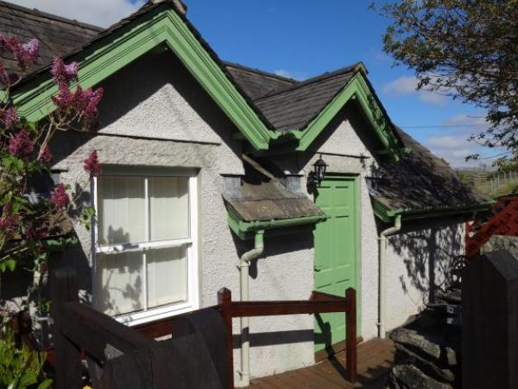

Welcome
Welcome. We want to make your holiday here a really enjoyable experience & we'll do our best to provide facilities which are suitable for your needs. This guide describes our facilites but if there is anything you are unsure of from our description, please don't hestiate to contact us and we'll do our best to answer your questions.
The cottage has its own private entrance from a quiet lane. It is on one level and is centrally heated. It has a sitting room and kitchen area, bedroom (superking size bed or twin beds) and a bathroom with separate bath and shower. Outside there is a patio, laundry room, private parking and use of an extensive garden.

At a Glance

Level Access
- There is level access from the main entrance to:
  - Bedroom: One
  - Laundry room off the patio

Bedrooms
- We have non-allergic bedding.

Level access bedrooms
- From the main entrance to the bedroom, there is level access.
- The route to the bedroom is 750mm wide, or more.
- The bedroom door is 750mm wide, or more.
- There is unobstructed floor space 1200mm by 900mm, or more.

Visual
- We have information in large print.

Getting here
Forest Field
Colton
Ulverston
Cumbria
LA12 8HF

Travel by public transport
- Although we use public transport where possible, the nearest bus service is two miles away. We recommend the use of a car or bicyle.

Travel by taxi
- You can get a taxi with A2b Taxis by calling 01229 587030.
- You can get a taxi with Paul's Taxis by calling 01229 586669.
- You can get a taxi with McKenna's Taxis by calling 01229 582180.

Parking
- There is parking near the venue. The parking is less than 50 metres from the main entrance. Parking is free.
- There is a drop-off point at the main entrance. The drop-off point does not have a dropped kerb.
- From the car park to the entrance, there is level access. The path is sloped.
- The route is 3000mm wide, or more.
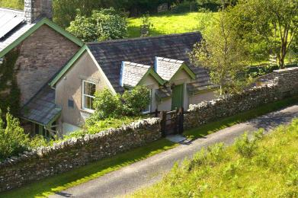
Cottage entrance

Arrival

Path to main entrance
- From the street to the main entrance, there is level access.
- There is a permanent ramp.
- The path is 1200mm wide, or more.
- The path is sloped.

Main entrance
- The door is 800mm wide.
- The main entrance has 0 steps.
- This entrance has a handrail.
- The main door is side hung and manual.
- When you arrive, we can help carry your luggage.

Getting around inside

Bedrooms
- All bedrooms have windows.
- Bedrooms have ceiling lights, bedside lamps and natural daylight.
- Lights are LED and energy saving. All bedrooms are non-smoking.
- We have non-allergic bedding.
- No bedrooms have fitted carpets.
- We can move the bedroom furniture, to improve accessibility.
- From the main entrance to this area, there is level access.
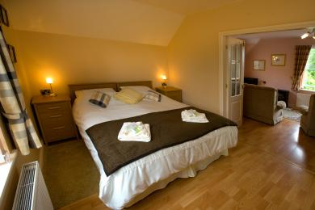
Bedroom (can be re-arranged as twin beds on request)

Accessible bedrooms

Accessible bedroom One
- The route to the bedroom is 750mm wide, or more. The bedroom door is 1200mm wide. There is 560mm at the side of the bed. The bed is 600mm high. The bedroom is flexible (either double or twin). The bedroom has an interconnecting room. The bathroom is ensuite. The bathroom door is 760mm wide.
- The bathroom has a separate shower. The bathroom has a bath.
- The bath has a handrail.
- The direction of transfer onto the toilet is to the front only. There is 300mm at the side of the toilet.
- There is 1000mm in front of the toilet. The toilet seat is 400mm high.
- The basin is 850mm high. There is no space under the basin.
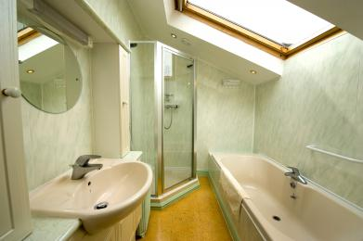
Bathroom

Laundry room off the patio
- From the main entrance to the laundry, there is level access. The route is 930mm wide, or more. The door is 730mm wide.
- We have an iron and ironing board. You can use the ironing board sitting down.
- Ironing board for use in main cottage
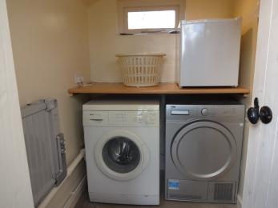
Interior of laundry room
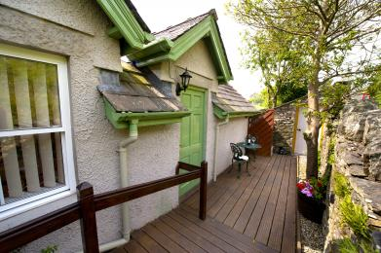
Access to laundry room from the patio

Self catering kitchen
- We have an open plan kitchen.
- From the main entrance to the kitchen, there is level access.
- The route is 700mm wide, or more.
- The work surface is available at a height between 650mm and 900mm.
- The hob is available at a height between 650mm and 900mm.
- The sink is available at a height between 650mm and 900mm.
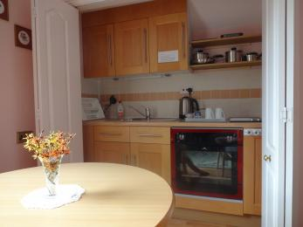
Kitchen area

Lounge
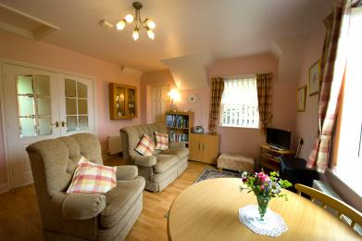
view from the lounge towards main entrance
- From the main entrance to the lounge, there is level access. The route is 600mm wide, or more.

Getting around outside
- From the main entrance to the gardens, there is level access.
- There is a permanent ramp.
- The route is sloped. The route is 1200mm wide, or more.
- The 3/4 acre garden is on a sloping site and has seats placed at strategic intervals. The summer house has decking around it and is, like the rest of the garden, accessible for motorised mobility scooters. There is step free access to the garden via the guest car park. The paths are mostly grass and can be slippery in wet weather.

Terrace
- From the main entrance to this area, there is level access. There is a permanent ramp. The route is 1200mm wide, or more.
- The entrance is 1200mm wide.
- To get to a table, there are no steps.
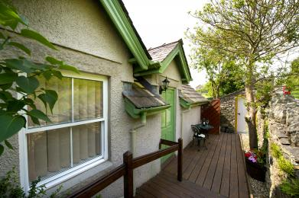
Terrace

Customer care support

Accessibility equipment
- We have an area to charge mobility scooters and battery powered wheelchairs.

Customer care support
- We have information in large print.

Guide last updated: 18 January 2019

